**Kubernetes Linux Acedemy**

Docker installation:

We are installing it on 3 nodes.

1 master:

bakumar2c.mylabserver.com

2 worker nodes:

bakumar3c.mylabserver.com,

bakumar4c.mylabserver.com

Run below commands in all 3 nodes

|  |
| --- |
| curl -fsSL https://download.docker.com/linux/ubuntu/gpg | sudo apt-key add -  add-apt-repository \  "deb [arch=amd64] https://download.docker.com/linux/ubuntu \  $(lsb_release -cs) \  stable"    apt-get update  apt-get install -y docker-ce=18.06.1~ce~3-0~ubuntu  apt-mark hold docker-ce  docker ps |

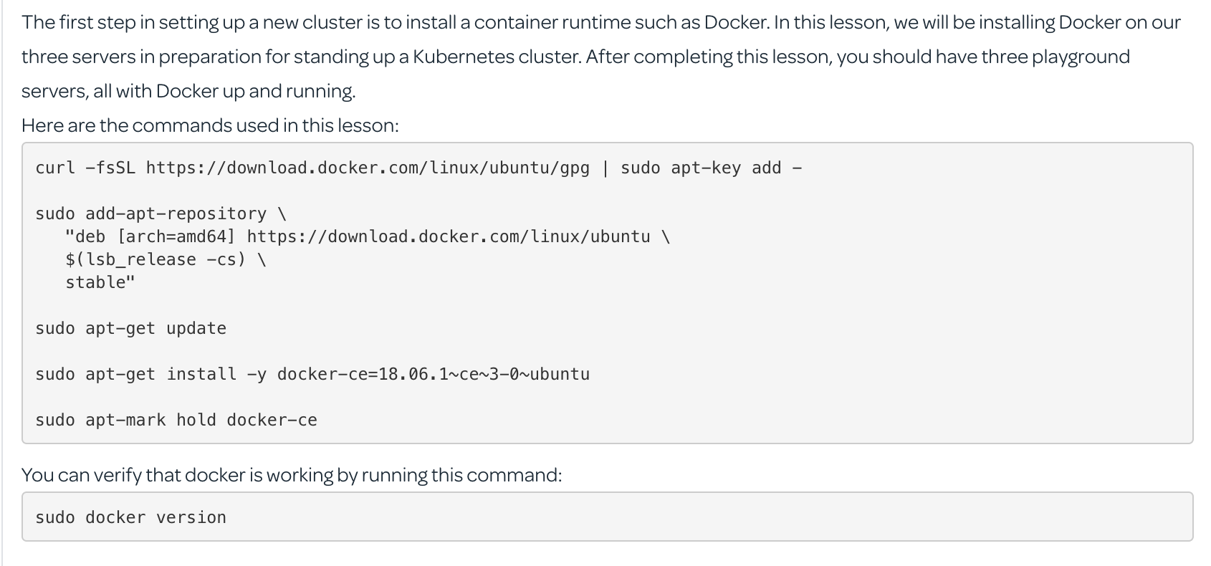

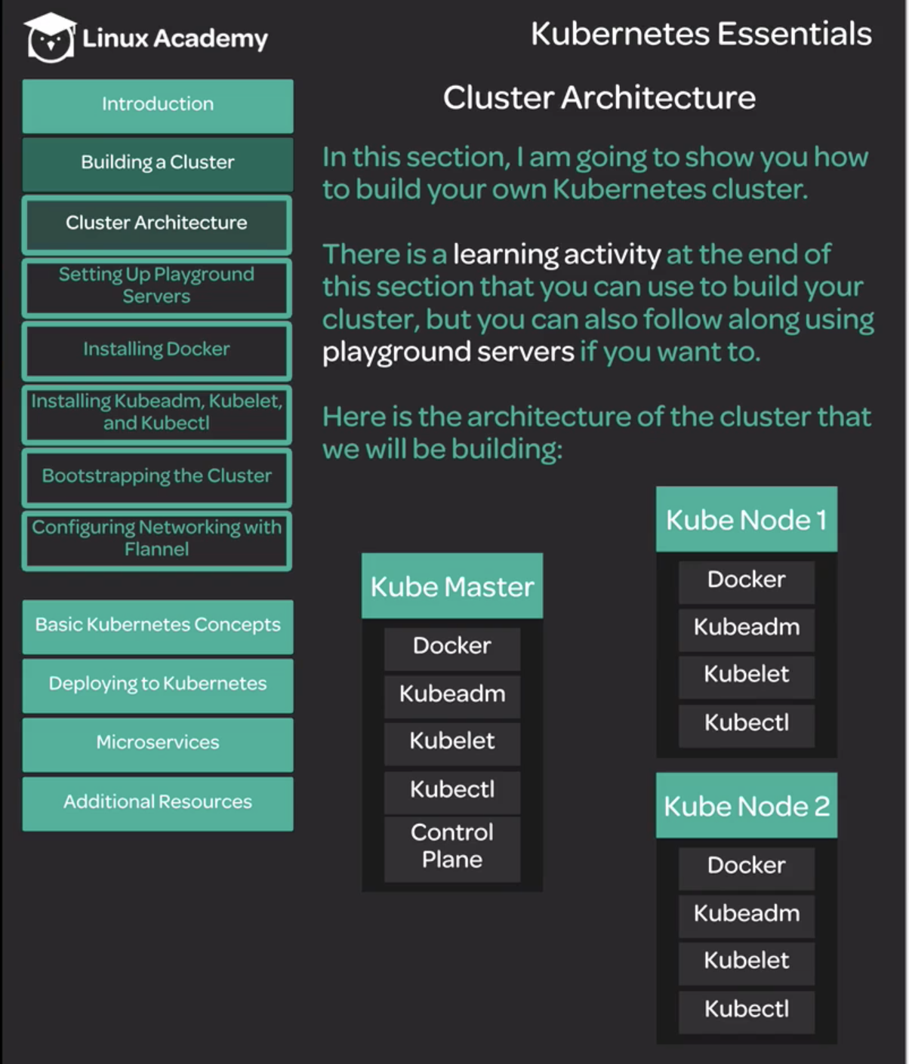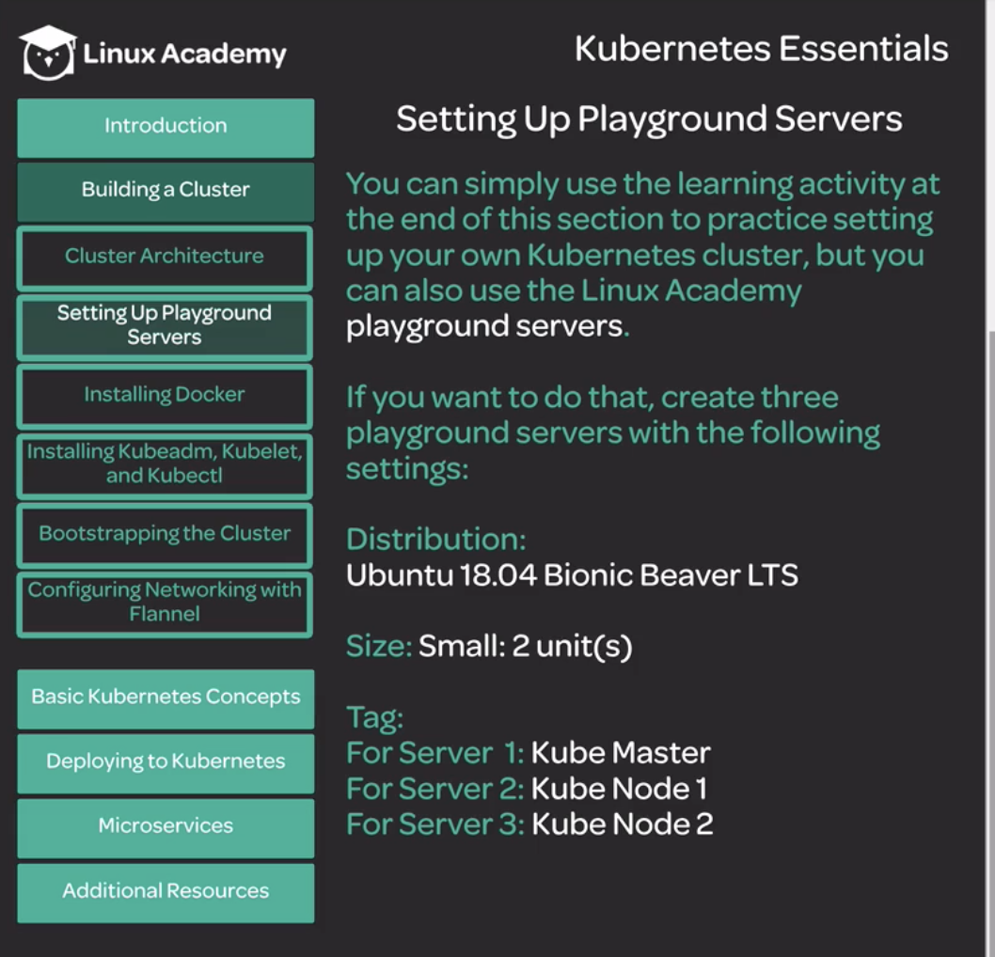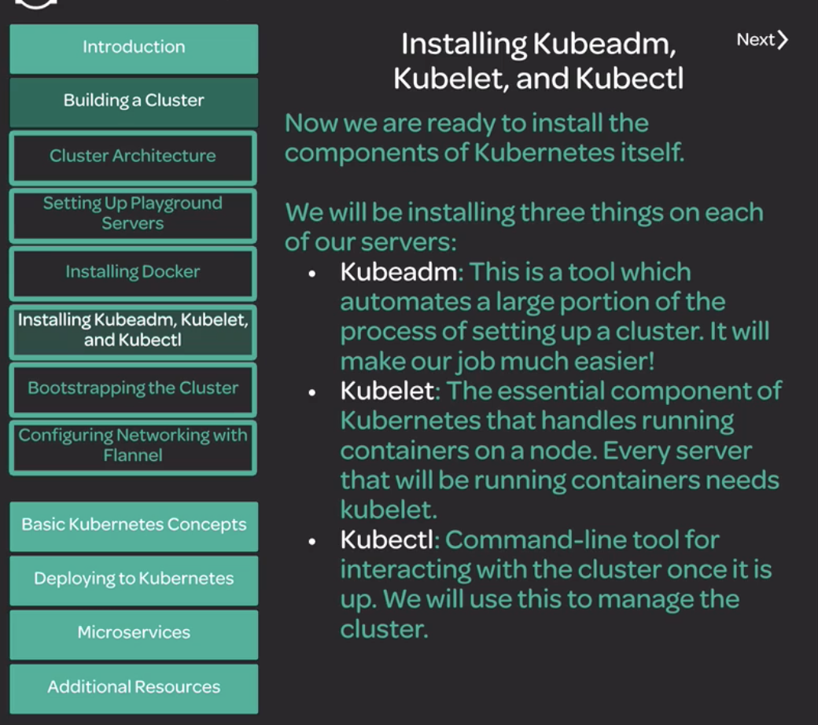

Install below Kubernetes steps In all 3 nodes

|  |
| --- |
| curl -s https://packages.cloud.google.com/apt/doc/apt-key.gpg | sudo apt-key add -  cat << EOF | sudo tee /etc/apt/sources.list.d/kubernetes.list  deb https://apt.kubernetes.io/ kubernetes-xenial main  EOF  apt-get update  apt-get install -y kubelet=1.12.7-00 kubeadm=1.12.7-00 kubectl=1.12.7-00  apt-mark hold kubelet kubeadm kubectl  kubeadm version |

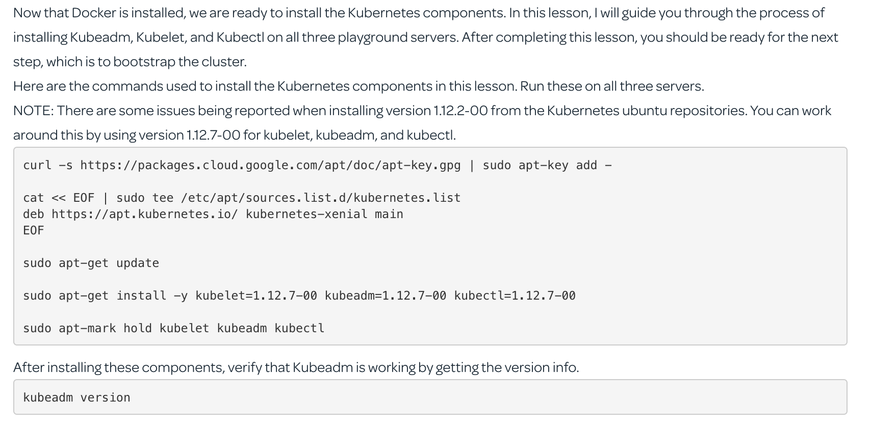

**Bootstrapping Kubernetes cluster**

Run Below commands in Master node.

|  |
| --- |
| kubeadm init --pod-network-cidr=10.244.0.0/16  <It will display set of further commands to execute on same master node along with token key to join worker nodes into cluster.>  Example:  [  To start using your cluster, you need to run the following as a regular user:  mkdir -p $HOME/.kube  sudo cp -i /etc/kubernetes/admin.conf $HOME/.kube/config  sudo chown $(id -u):$(id -g) $HOME/.kube/config  You can now join any number of machines by running the following on each node  as root:  kubeadm join 172.31.41.71:6443 --token ocf5ib.xzicjfjwt7slt271 --discovery-token-ca-cert-hash sha256:e6332502487041e1314afec51b7a31486edc12d1a41861c1380d8791816bf117  ]  Run above shown commands in master node:  mkdir -p $HOME/.kube  sudo cp -i /etc/kubernetes/admin.conf $HOME/.kube/config  sudo chown $(id -u):$(id -g) $HOME/.kube/config  Then for checking kubectl  #kubectl version  output:  Client Version: …  Server Version:.. |

Run above master node shown output of “toker join “in worker node

|  |
| --- |
| From bakumar3c.mylabserver.com,  sudo kubeadm join 172.31.41.71:6443 --token ocf5ib.xzicjfjwt7slt271 --discovery-token-ca-cert-hash sha256:e6332502487041e1314afec51b7a31486edc12d1a41861c1380d8791816bf117  From bakumar4c.mylabserver.com  sudo kubeadm join 172.31.41.71:6443 --token ocf5ib.xzicjfjwt7slt271 --discovery-token-ca-cert-hash sha256:e6332502487041e1314afec51b7a31486edc12d1a41861c1380d8791816bf117 |

Once ran above commands, we run below command from Master node to see list of joined nodes

|  |
| --- |
| root@bakumar2c:~# kubectl get nodes  NAME STATUS ROLES AGE VERSION  bakumar2c.mylabserver.com NotReady master 8m5s v1.12.7  bakumar3c.mylabserver.com NotReady <none> 3m46s v1.12.7  bakumar4c.mylabserver.com NotReady <none> 3m31s v1.12.7  Till we setup networking for cluster, “STATUS” will show up in “Not Ready” |

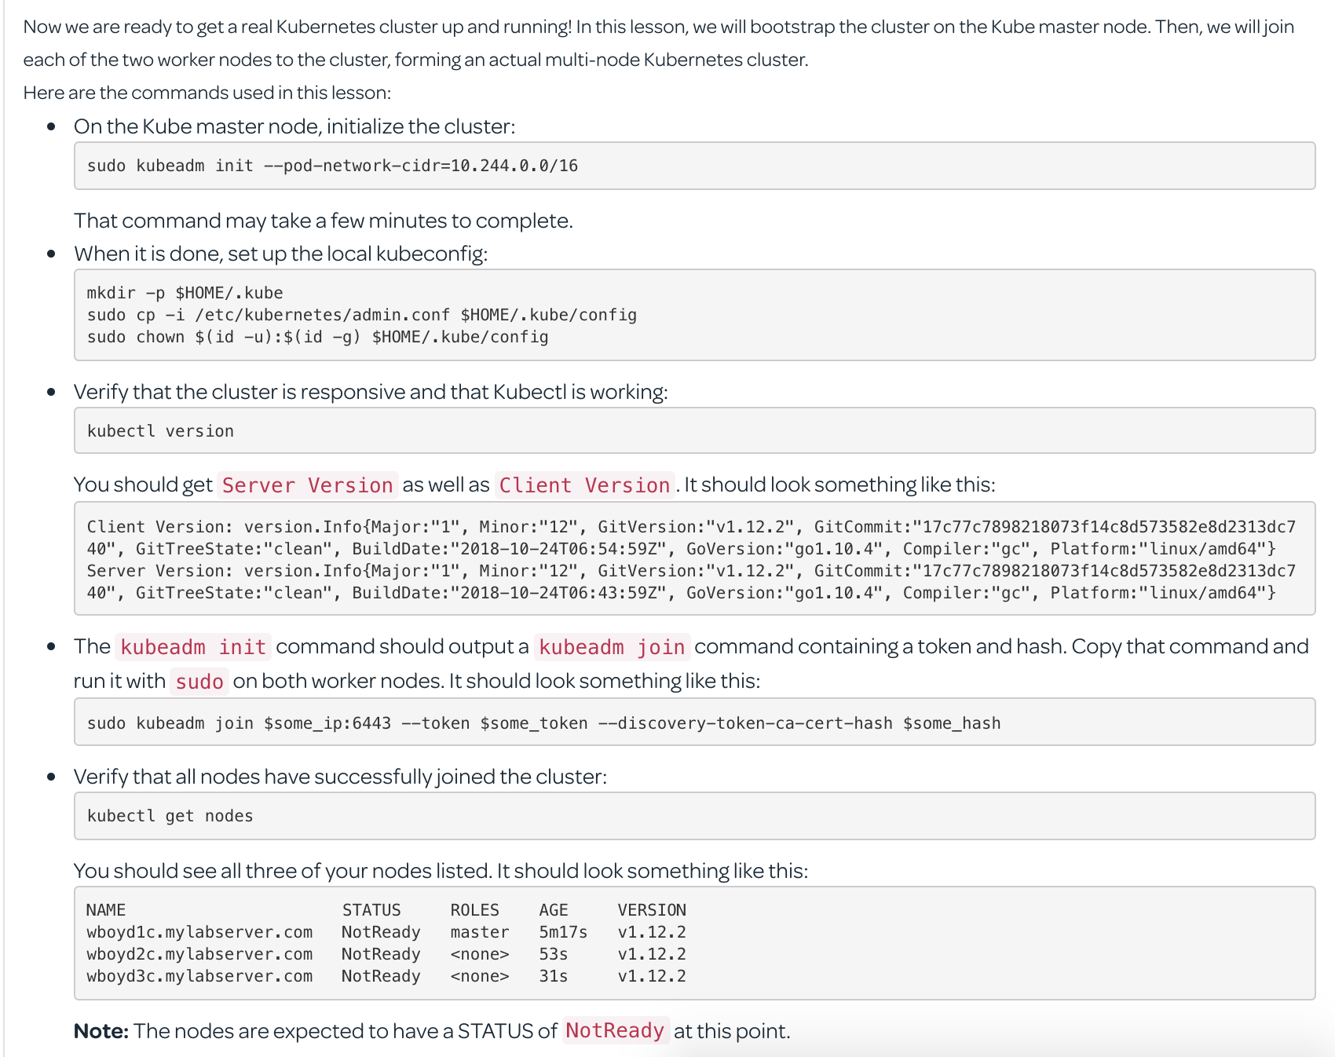

**Kubenetes- Setting up networking with Flannel**

Run below commands in all nodes-master & workers in cluster

|  |
| --- |
| root@bakumar2c:~# echo "net.bridge.bridge-nf-call-iptables=1" | sudo tee -a /etc/sysctl.conf  net.bridge.bridge-nf-call-iptables=1  root@bakumar2c:~# sysctl -p  net.bridge.bridge-nf-call-iptables = 1  root@bakumar2c:~# |

Install Flannel in the cluster by running this only on the Master node:

|  |
| --- |
| root@bakumar2c:~# kubectl apply -f https://raw.githubusercontent.com/coreos/flannel/bc79dd1505b0c8681ece4de4c0d86c5cd2643275/Documentation/kube-flannel.yml  clusterrole.rbac.authorization.k8s.io/flannel created  clusterrolebinding.rbac.authorization.k8s.io/flannel created  serviceaccount/flannel created  configmap/kube-flannel-cfg created  daemonset.extensions/kube-flannel-ds-amd64 created  daemonset.extensions/kube-flannel-ds-arm64 created  daemonset.extensions/kube-flannel-ds-arm created  daemonset.extensions/kube-flannel-ds-ppc64le created  daemonset.extensions/kube-flannel-ds-s390x created  Now we setted up networking with flannel, check the nodes status.  root@bakumar2c:~# kubectl get nodes  NAME STATUS ROLES AGE VERSION  bakumar2c.mylabserver.com Ready master 16m v1.12.7  bakumar3c.mylabserver.com Ready <none> 12m v1.12.7  bakumar4c.mylabserver.com Ready <none> 12m v1.12.7  root@bakumar2c:~#  Check the namespace of “kube-system”, which by default all containers are created under this.  root@bakumar2c:~# kubectl get pods -n kube-system  NAME READY STATUS RESTARTS AGE  coredns-bb49df795-b4hzd 1/1 Running 0 19m  coredns-bb49df795-fgj4j 1/1 Running 0 19m  etcd-bakumar2c.mylabserver.com 1/1 Running 0 18m  kube-apiserver-bakumar2c.mylabserver.com 1/1 Running 0 18m  kube-controller-manager-bakumar2c.mylabserver.com 1/1 Running 0 18m  kube-flannel-ds-amd64-jmdxn 1/1 Running 0 3m9s  kube-flannel-ds-amd64-rn6xj 1/1 Running 0 3m9s  kube-flannel-ds-amd64-smn2n 1/1 Running 0 3m9s  kube-proxy-hxxbk 1/1 Running 0 19m  kube-proxy-l4n6s 1/1 Running 0 14m  kube-proxy-sqrkh 1/1 Running 0 15m  kube-scheduler-bakumar2c.mylabserver.com 1/1 Running 0 18m  The kube-flannel is responsible for setting up networking layer in kebernetes. |

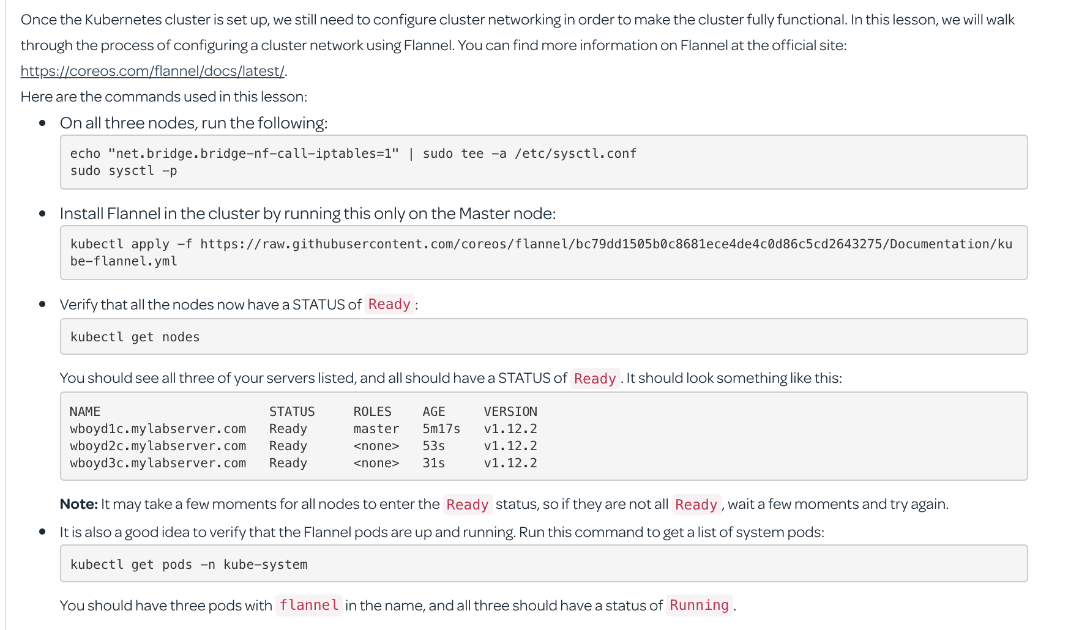

**Containers and Pods**

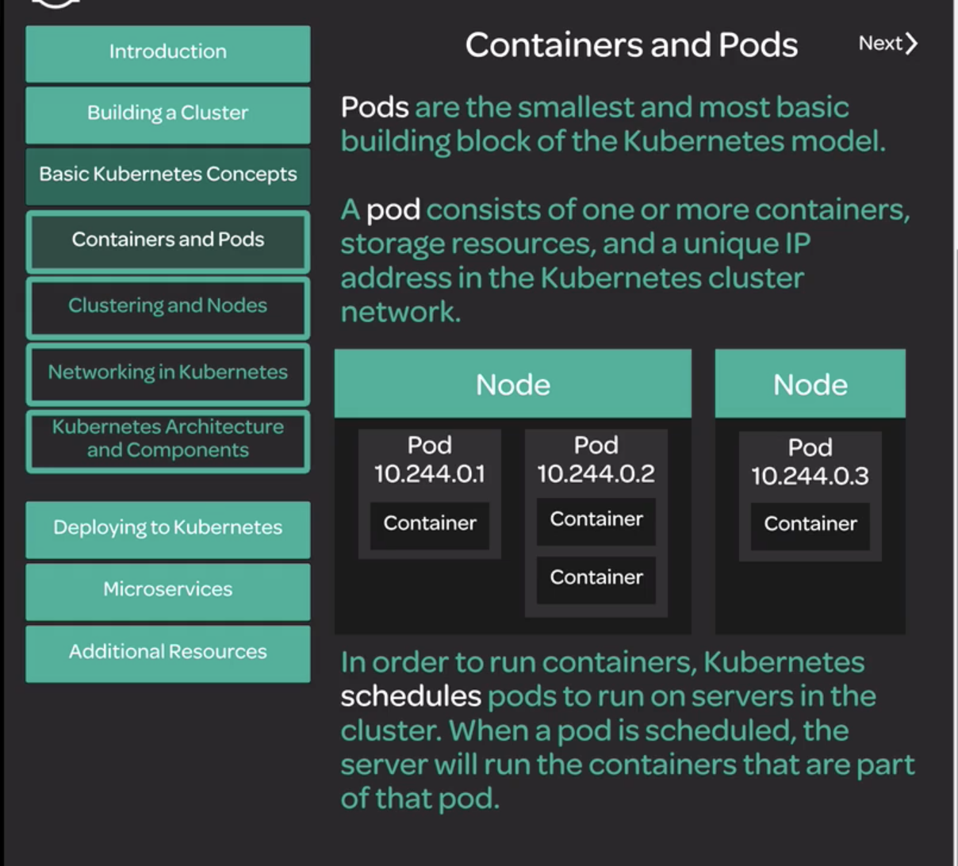

**Sample YAML file to create nginx image**

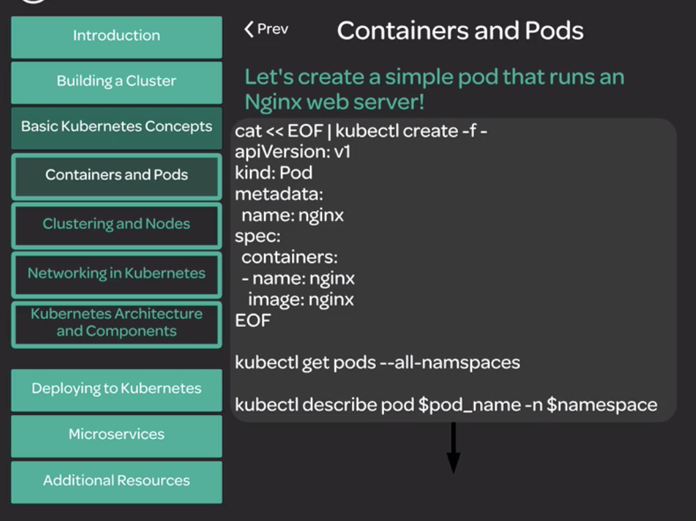

|  |
| --- |
| **Run below in Master node to create a nginx image**  cat << EOF | kubectl create -f -  apiVersion: v1  kind: Pod  metadata:  name: nginx  spec:  containers:  - name: nginx  image: nginx  EOF  root@bakumar2c:/opt# kubectl get pods  NAME READY STATUS RESTARTS AGE  nginx 1/1 Running 0 24s  more info about created pod “nginx”  root@bakumar2c:/opt# kubectl describe pod nginx  Name: nginx  Namespace: default  Priority: 0  PriorityClassName: <none>  Node: bakumar4c.mylabserver.com/172.31.47.144  Start Time: Mon, 14 Oct 2019 06:46:27 +0000  Labels: <none>  Annotations: <none>  Status: Running  IP: 10.244.2.2  Containers:  nginx:  Container ID: docker://13c158c33b40ac51c3091b6e76662984c214d6ab5caf3bcd040a44431b9039a0  Image: nginx  Image ID: docker-pullable://nginx@sha256:aeded0f2a861747f43a01cf1018cf9efe2bdd02afd57d2b11fcc7fcadc16ccd1  Port: <none>  Host Port: <none>  State: Running  Started: Mon, 14 Oct 2019 06:46:38 +0000  Ready: True  Restart Count: 0  Environment: <none>  Mounts:  /var/run/secrets/kubernetes.io/serviceaccount from default-token-chmls (ro)  Conditions:  Type Status  Initialized True  Ready True  ContainersReady True  PodScheduled True  Volumes:  default-token-chmls:  Type: Secret (a volume populated by a Secret)  SecretName: default-token-chmls  Optional: false  QoS Class: BestEffort  Node-Selectors: <none>  Tolerations: node.kubernetes.io/not-ready:NoExecute for 300s  node.kubernetes.io/unreachable:NoExecute for 300s  Events:  Type Reason Age From Message  ---- ------ ---- ---- -------  Normal Scheduled 4m43s default-scheduler Successfully assigned default/nginx to bakumar4c.mylabserver.com  Normal Pulling 4m42s kubelet, bakumar4c.mylabserver.com pulling image "nginx"  Normal Pulled 4m34s kubelet, bakumar4c.mylabserver.com Successfully pulled image "nginx"  Normal Created 4m32s kubelet, bakumar4c.mylabserver.com Created container  Normal Started 4m32s kubelet, bakumar4c.mylabserver.com Started container  root@bakumar2c:/opt# |

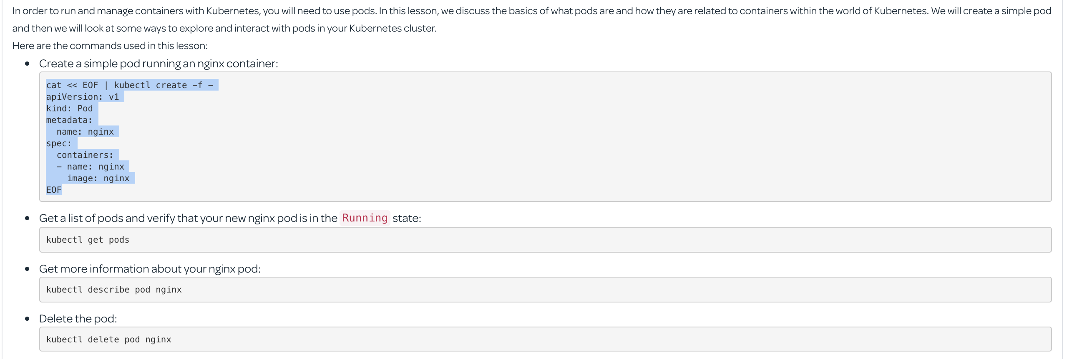

Delete pod

|  |
| --- |
| root@bakumar2c:/opt#  root@bakumar2c:/opt# kubectl delete pod nginx  pod "nginx" deleted  root@bakumar2c:/opt# |

**Clustering and nodes**

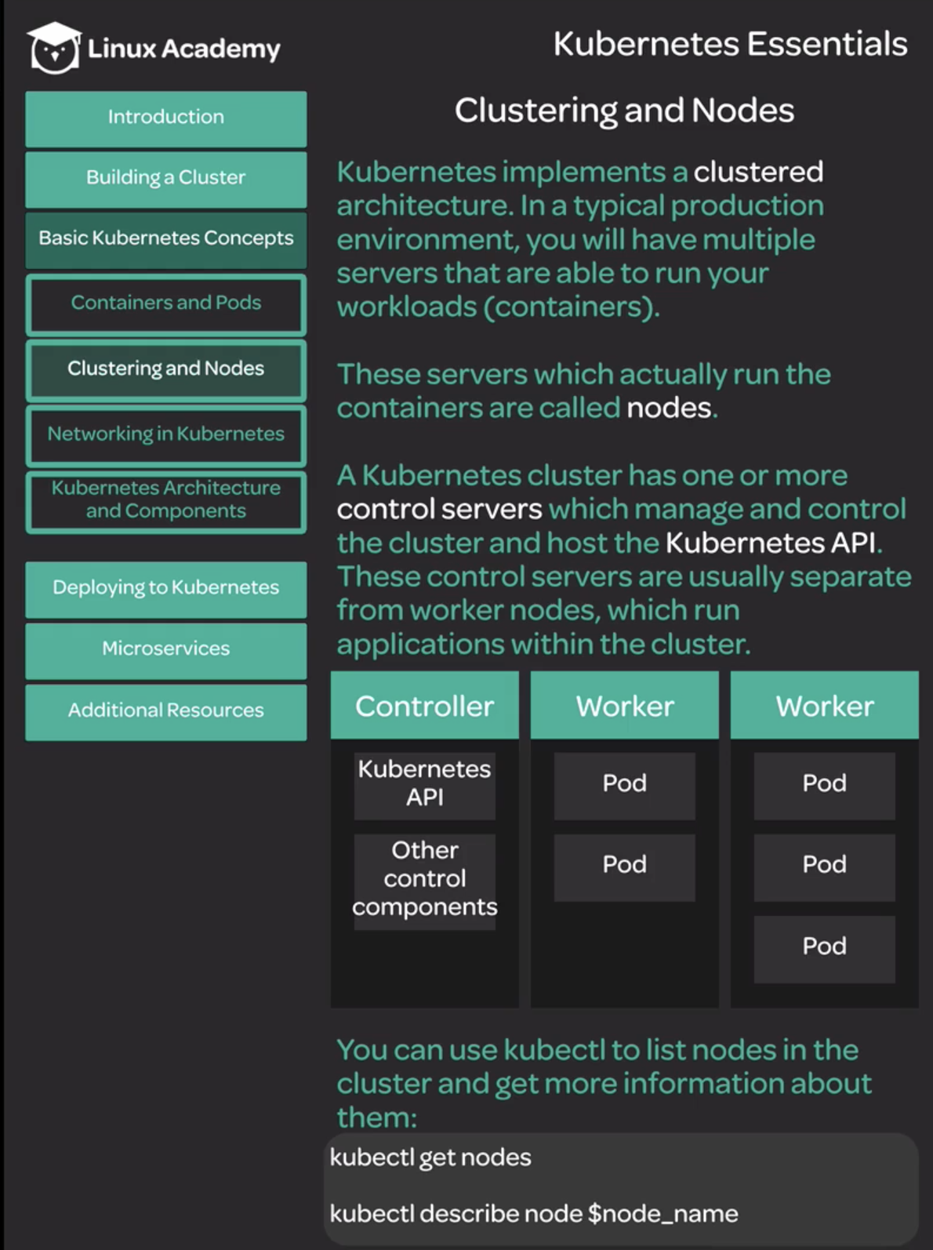

Master node -> Kubernetes Control nodes

Worker nodes are responsible for running actual applications

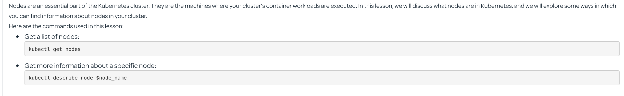

**Networking in Kuberenetes**

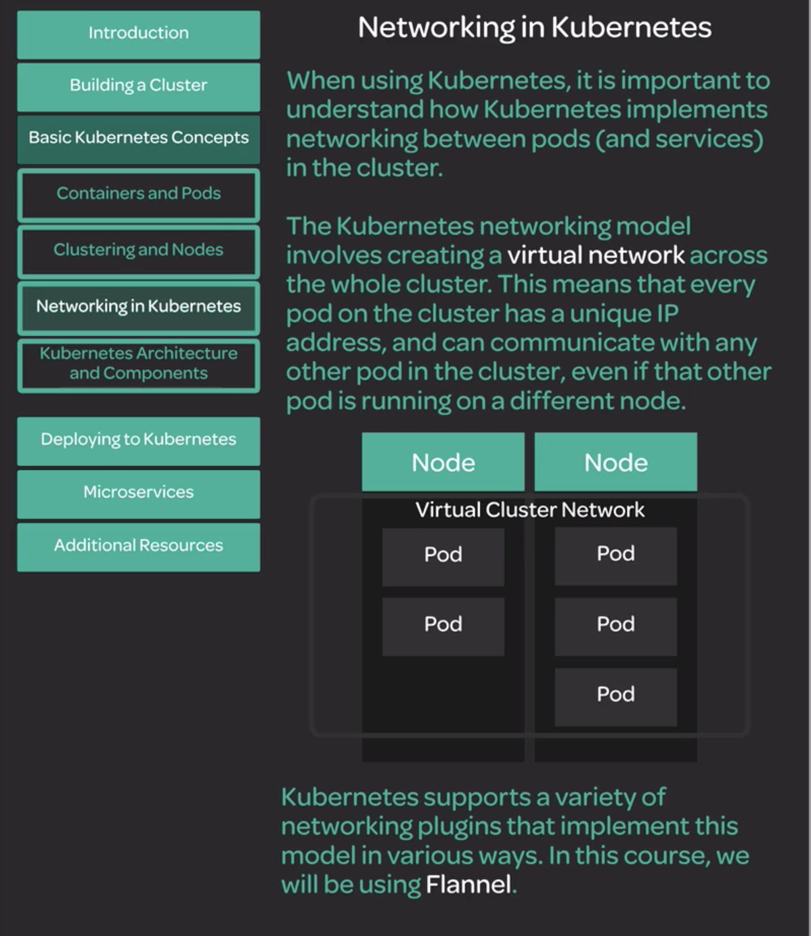

|  |
| --- |
| Run it in Master node  cat << EOF | kubectl create -f -  apiVersion: apps/v1  kind: Deployment  metadata:  name: nginx  labels:  app: nginx  spec:  replicas: 2  selector:  matchLabels:  app: nginx  template:  metadata:  labels:  app: nginx  spec:  containers:  - name: nginx  image: nginx:1.15.4  ports:  - containerPort: 80  EOF  root@bakumar2c:/opt# kubectl get pods  NAME READY STATUS RESTARTS AGE  nginx-d55b94fd-r25rc 1/1 Running 0 73s  nginx-d55b94fd-w2rmv 1/1 Running 0 73s |

|  |
| --- |
| cat << EOF | kubectl create -f -  apiVersion: v1  kind: Pod  metadata:  name: busybox  spec:  containers:  - name: busybox  image: radial/busyboxplus:curl  args:  - sleep  - "1000"  EOF  --  root@bakumar2c:/opt# kubectl get pods  NAME READY STATUS RESTARTS AGE  busybox 1/1 Running 0 37s  nginx-d55b94fd-r25rc 1/1 Running 0 2m41s  nginx-d55b94fd-w2rmv 1/1 Running 0 2m41s  we can get more wider output:  root@bakumar2c:/opt# kubectl get pods -o wide  NAME READY STATUS RESTARTS AGE IP NODE NOMINATED NODE  busybox 1/1 Running 0 70s 10.244.2.4 bakumar4c.mylabserver.com <none>  nginx-d55b94fd-r25rc 1/1 Running 0 3m14s 10.244.1.4 bakumar3c.mylabserver.com <none>  nginx-d55b94fd-w2rmv 1/1 Running 0 3m14s 10.244.2.3 bakumar4c.mylabserver.com <none>  Now we will try to reach one Pod(Ex: Master node-busybox-10.244.2.4 ) to another Pod(worker node2- nginx-10.244.2.3 )  Note:Here 10.244.2.3 is nginx node3 and busybox is master node1.  root@bakumar2c:/opt# kubectl exec busybox -- curl 10.244.2.3  % Total % Received % Xferd Average Speed Time Time Time Current  Dload Upload Total Spent Left Speed  100 612 100 612 0 0 525k 0 --:--:-- --:--:-- --:--:-- 597k  <!DOCTYPE html>  <html>  <head>  <title>Welcome to nginx!</title>  <style>  body {  width: 35em;  margin: 0 auto;  font-family: Tahoma, Verdana, Arial, sans-serif;  }  </style>  </head>  <body>  <h1>Welcome to nginx!</h1>  <p>If you see this page, the nginx web server is successfully installed and  working. Further configuration is required.</p>  <p>For online documentation and support please refer to  <a href="http://nginx.org/">nginx.org</a>.<br/>  Commercial support is available at  <a href="http://nginx.com/">nginx.com</a>.</p>  <p><em>Thank you for using nginx.</em></p>  </body>  </html>  It is possible to interact one POD to another POD using virtual network of Kubernetes.(As shown in “Networking in Kubernees ” doc above) |

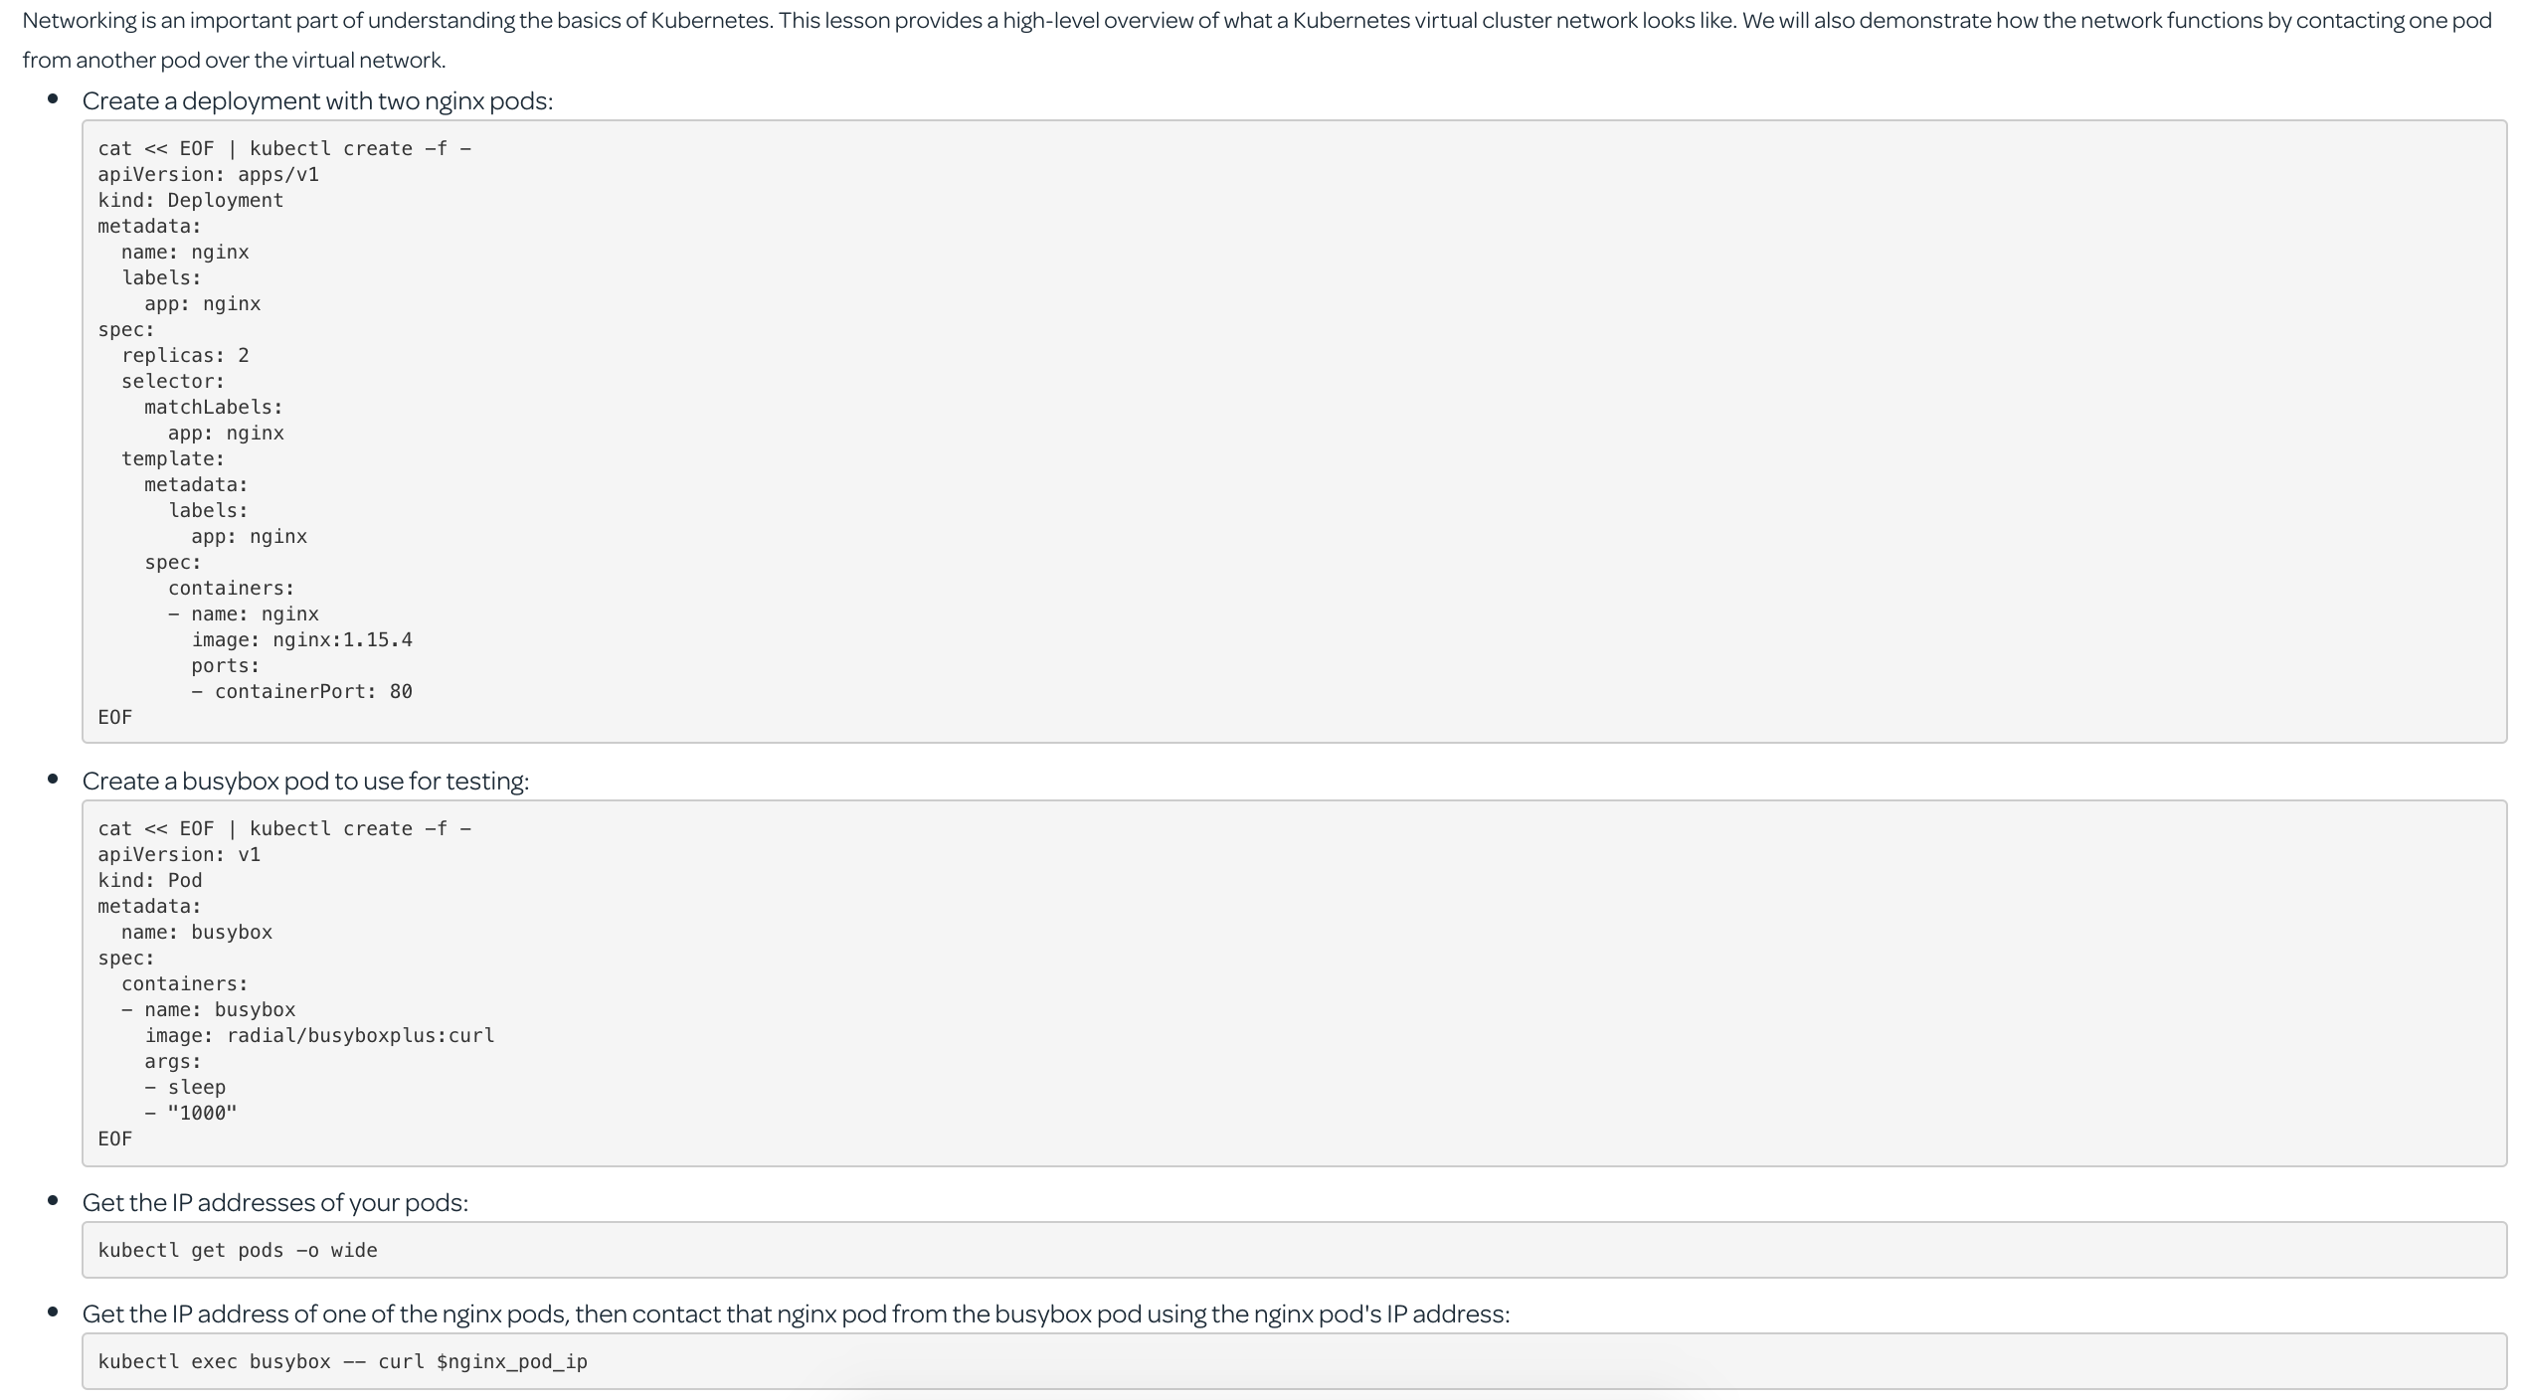

**Kubernetes Architecture and Components**

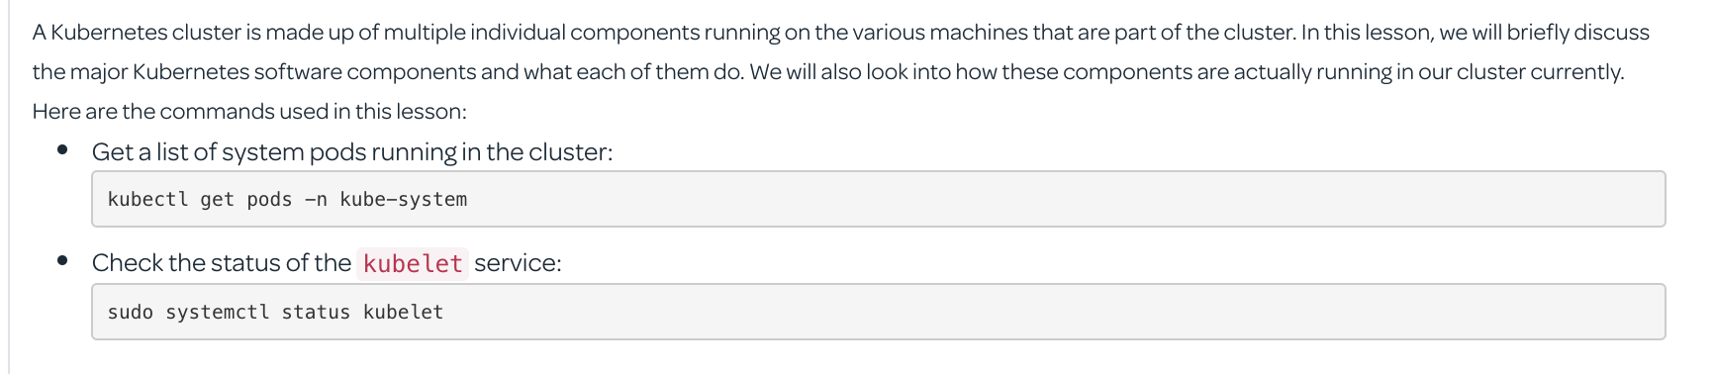

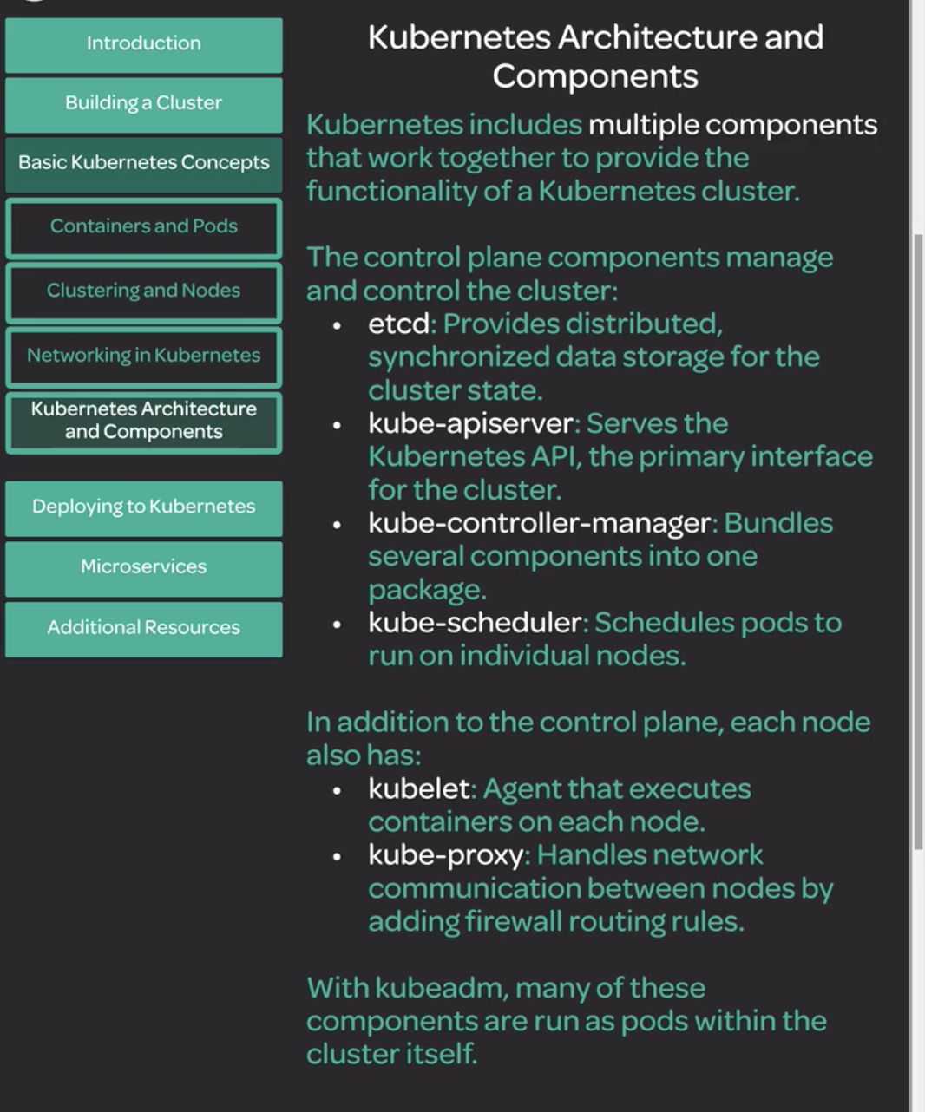

**Kubelet**

Its is an agent run in each kuberenetes cluster node and acts as a middle man between container(docker) and Kuberenetes api

|  |
| --- |
| root@bakumar2c:~# systemctl status kubelet  ● kubelet.service - kubelet: The Kubernetes Node Agent  Loaded: loaded (/lib/systemd/system/kubelet.service; enabled; vendor preset: enabled)  Drop-In: /etc/systemd/system/kubelet.service.d  └─10-kubeadm.conf  Active: active (running) since Mon 2019-10-14 06:16:35 UTC; 1h 19min ago  Docs: https://kubernetes.io/docs/home/  Main PID: 27212 (kubelet)  Tasks: 17 (limit: 2318)  CGroup: /system.slice/kubelet.service  └─27212 /usr/bin/kubelet --bootstrap-kubeconfig=/etc/kubernetes/bootstrap-kubelet.conf --kubeconfig=/etc/kubernetes/kubelet.conf --config=/ |

deployments

|  |
| --- |
| cat <<EOF | kubectl create -f -  apiVersion: apps/v1  kind: Deployment  metadata:  name: nginx-deployment  labels:  app: nginx  spec:  replicas: 2  selector:  matchLabels:  app: nginx  template:  metadata:  labels:  app: nginx  spec:  containers:  - name: nginx  image: nginx:1.15.4  ports:  - containerPort: 80  EOF  root@bakumar2c:~# kubectl get deployments  NAME DESIRED CURRENT UP-TO-DATE AVAILABLE AGE  nginx 2 2 2 2 39m  nginx-deployment 2 2 2 2 22s  root@bakumar2c:~# kubectl get deployments -o wide  NAME DESIRED CURRENT UP-TO-DATE AVAILABLE AGE CONTAINERS IMAGES SELECTOR  nginx 2 2 2 2. 39m nginx nginx:1.15.4 app=nginx  nginx-deployment 2 2 2 2 27s nginx nginx:1.15.4 app=nginx  Wide description  oot@bakumar2c:~# kubectl describe deployments nginx-deployment  Name: nginx-deployment  Namespace: default  CreationTimestamp: Mon, 14 Oct 2019 07:43:11 +0000  Labels: app=nginx  Annotations: deployment.kubernetes.io/revision: 1  Selector: app=nginx  Replicas: 2 desired | 2 updated | 2 total | 2 available | 0 unavailable  StrategyType: RollingUpdate  MinReadySeconds: 0  RollingUpdateStrategy: 25% max unavailable, 25% max surge  Pod Template:  Labels: app=nginx  Containers:  nginx:  Image: nginx:1.15.4  Port: 80/TCP  Host Port: 0/TCP  Environment: <none>  Mounts: <none>  Volumes: <none>  Conditions:  Type Status Reason  ---- ------ ------  Available True MinimumReplicasAvailable  Progressing True NewReplicaSetAvailable  OldReplicaSets: <none>  NewReplicaSet: nginx-deployment-d55b94fd (2/2 replicas created)  Events:  Type Reason Age From Message  ---- ------ ---- ---- -------  Normal ScalingReplicaSet 9m54s deployment-controller Scaled up replica set nginx-deployment-d55b94fd to 2  root@bakumar2c:~# |



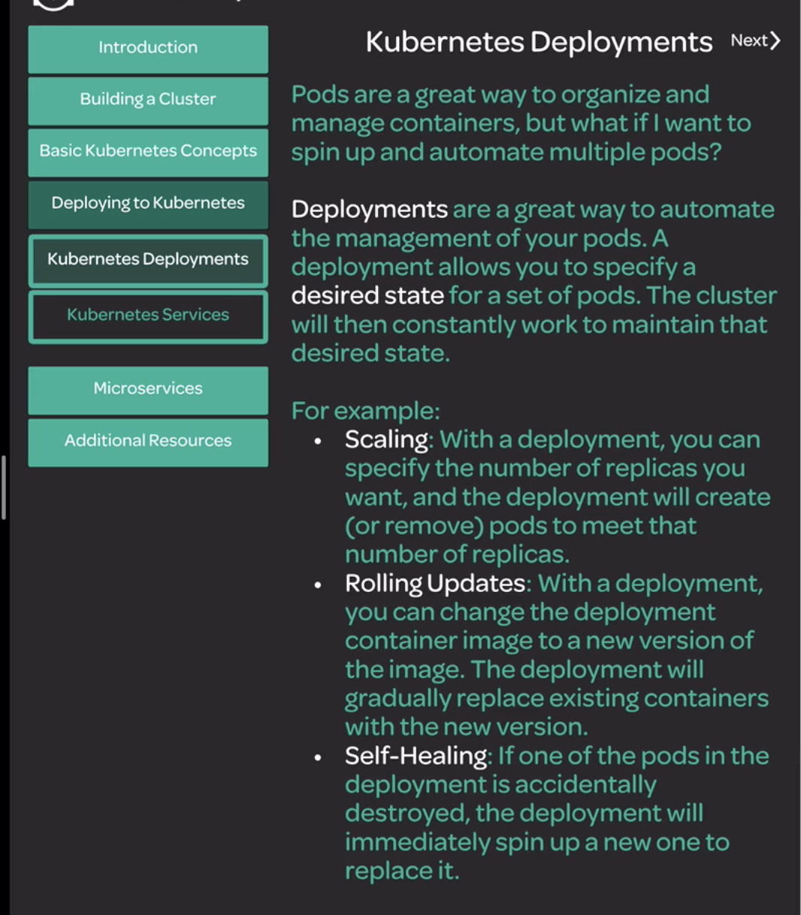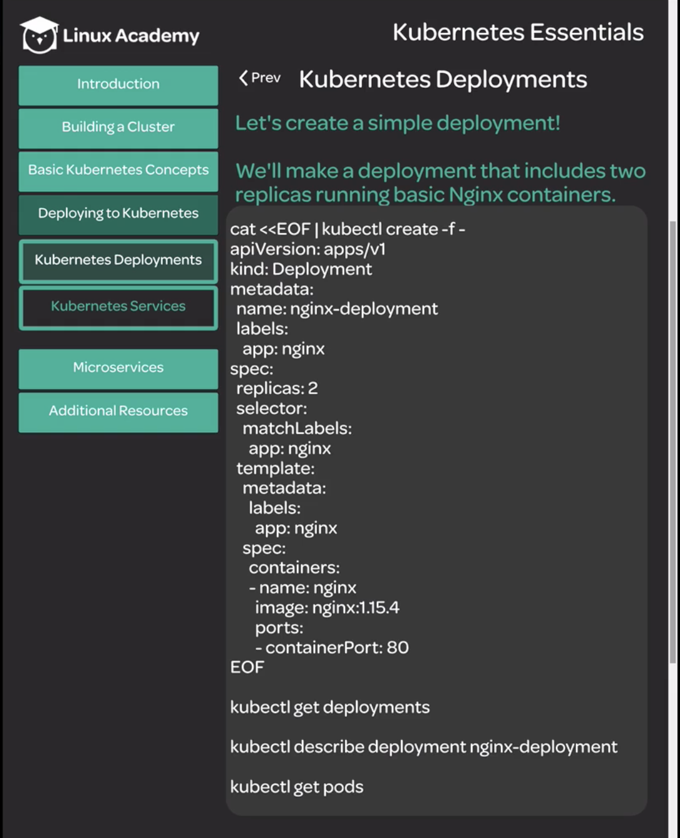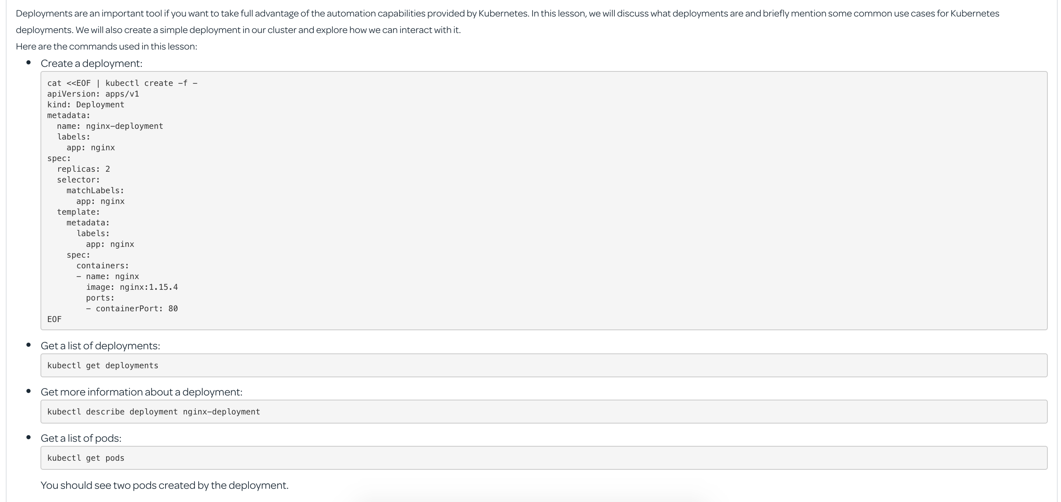

**Kuberenets services**

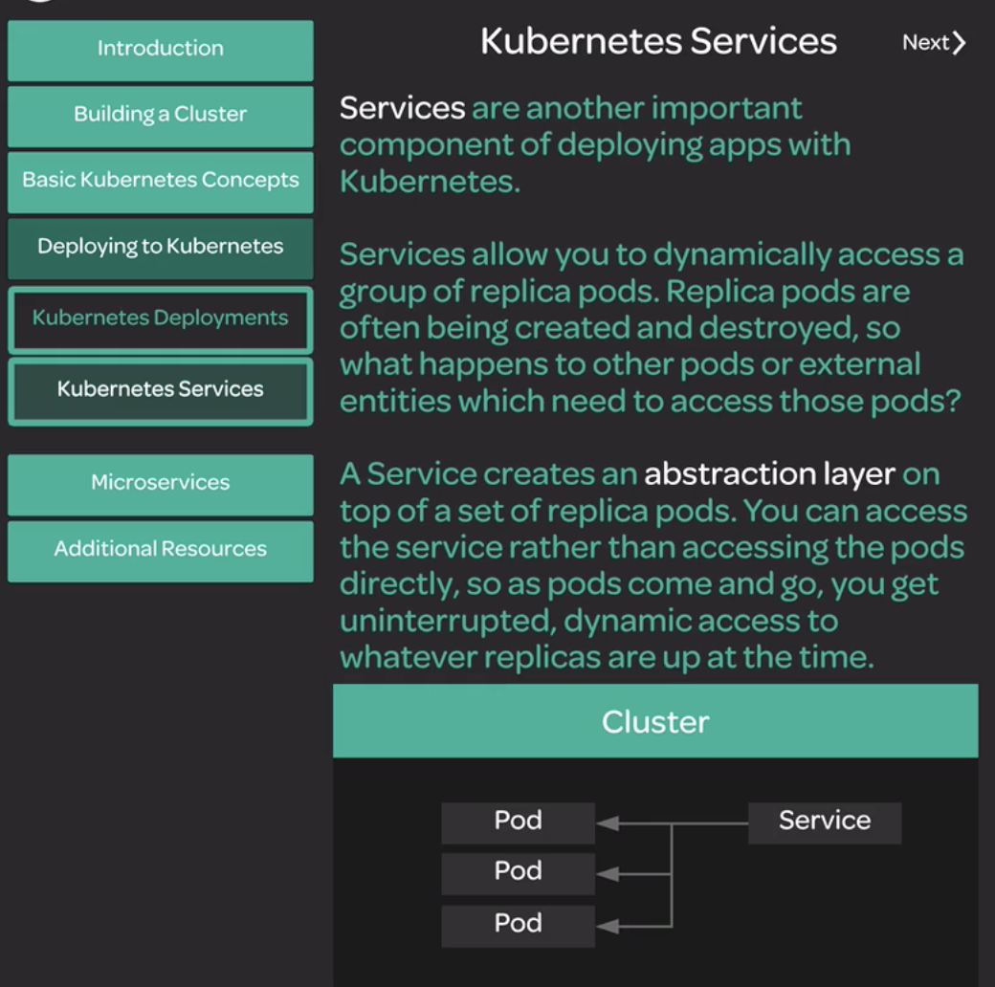

**Kubenetes services**

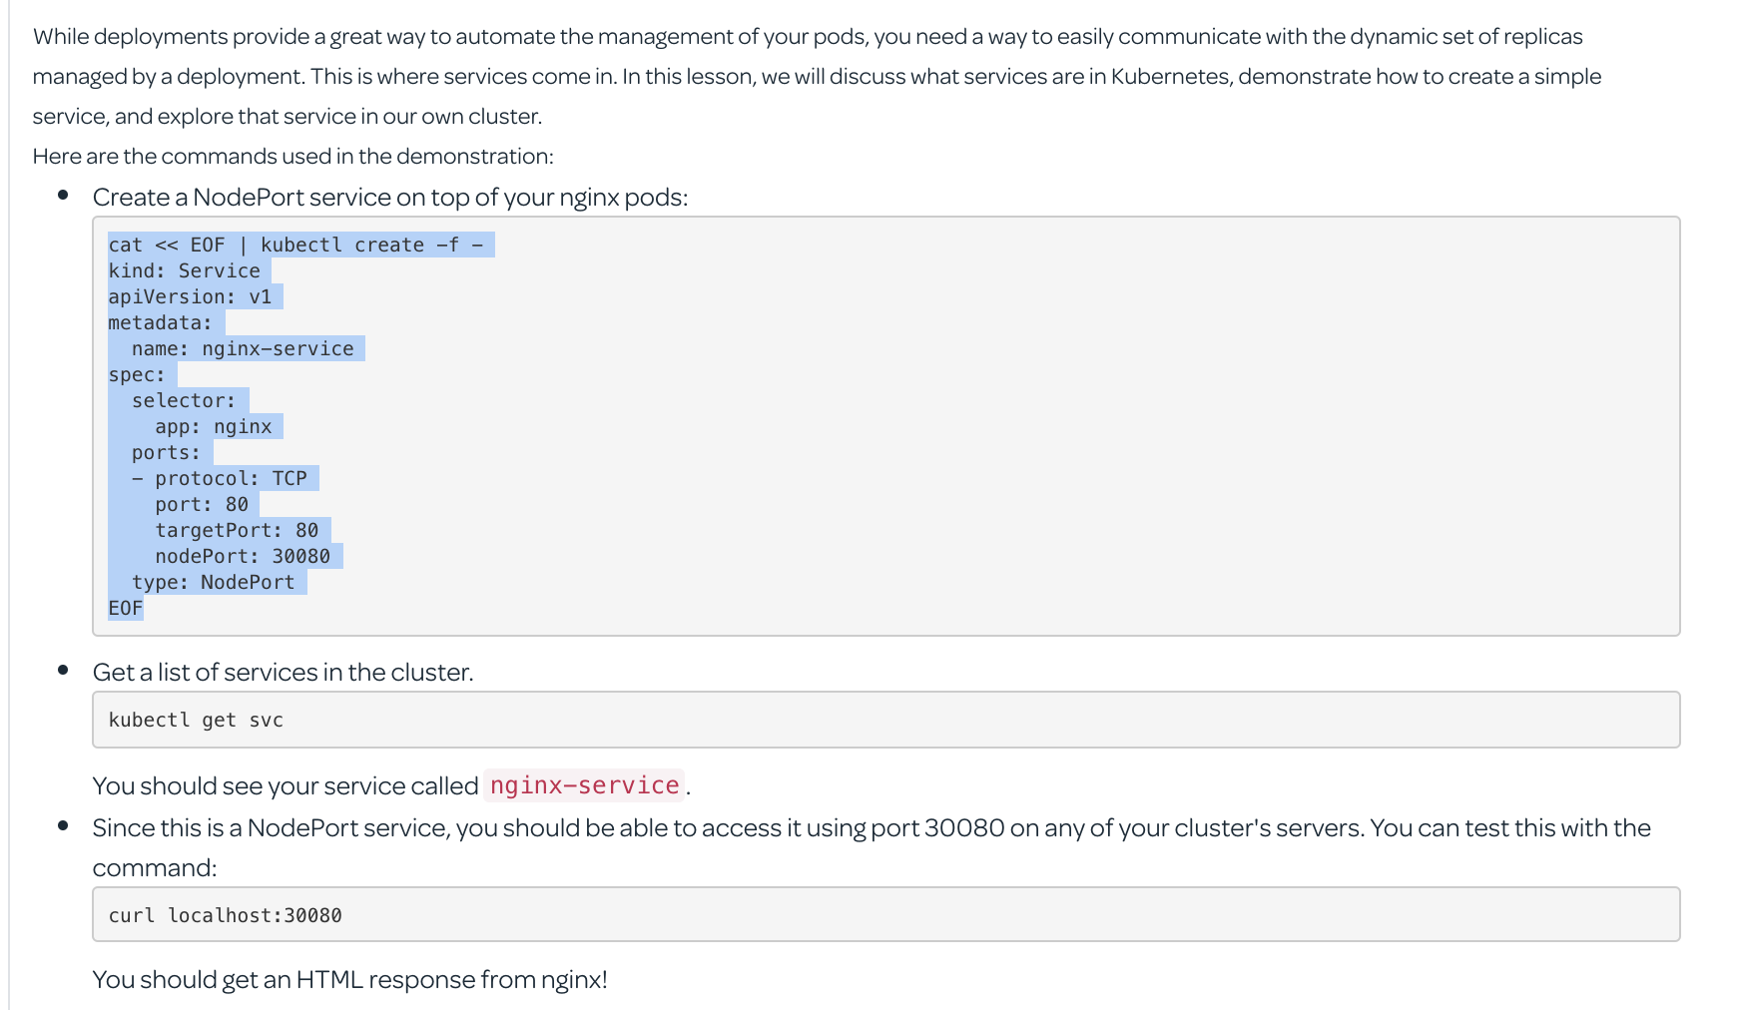

|  |
| --- |
| root@bakumar2c:~# cat << EOF | kubectl create -f -  > kind: Service  > apiVersion: v1  > metadata:  > name: nginx-service  > spec:  > selector:  > app: nginx  > ports:  > - protocol: TCP  > port: 80  > targetPort: 80  > nodePort: 30080  > type: NodePort  > EOF  service/nginx-service created  root@bakumar2c:~# kubectl get services  NAME TYPE CLUSTER-IP EXTERNAL-IP PORT(S) AGE  kubernetes ClusterIP 10.96.0.1 <none> 443/TCP 111m  nginx-service NodePort 10.97.179.188 <none> 80:30080/TCP 14s  root@bakumar2c:~# kubectl get svc  NAME TYPE CLUSTER-IP EXTERNAL-IP PORT(S) AGE  kubernetes ClusterIP 10.96.0.1 <none> 443/TCP 111m  nginx-service NodePort 10.97.179.188 <none> 80:30080/TCP 17s  root@bakumar2c:~#  root@bakumar2c:~# curl localhost:30080  <!DOCTYPE html>  <html>  <head>  <title>Welcome to nginx!</title>  <style>  body {  width: 35em;  margin: 0 auto;  font-family: Tahoma, Verdana, Arial, sans-serif;  }  </style>  </head>  <body>  <h1>Welcome to nginx!</h1>  <p>If you see this page, the nginx web server is successfully installed and  working. Further configuration is required.</p>  <p>For online documentation and support please refer to  <a href="http://nginx.org/">nginx.org</a>.<br/>  Commercial support is available at  <a href="http://nginx.com/">nginx.com</a>.</p>  <p><em>Thank you for using nginx.</em></p>  </body>  </html>  root@bakumar2c:~#  or  root@bakumar2c:~# curl 172.31.40.125:30080  <!DOCTYPE html>  <html>  <head>  <title>Welcome to nginx!</title>  <body>  <h1>Welcome to nginx!</h1>  <  Here "172.31.40.125" is the Master node private IP.  Similary using Private IP Addresses of worker nodes ,we can connect to pods/containers.  **from workernode2**  root@bakumar2c:~# curl 172.31.41.71:30080  <head>  <title>Welcome to nginx!</title>  <h1>Welcome to nginx!</h1>  **from workernode1**  root@bakumar2c:~# curl 172.31.47.144:30080  <title>Welcome to nginx!</title>  </head>  <body>  <h1>Welcome to nginx!</h1>  root@bakumar2c:~# |

**Kuberenetes Microsercvices and Deployments**

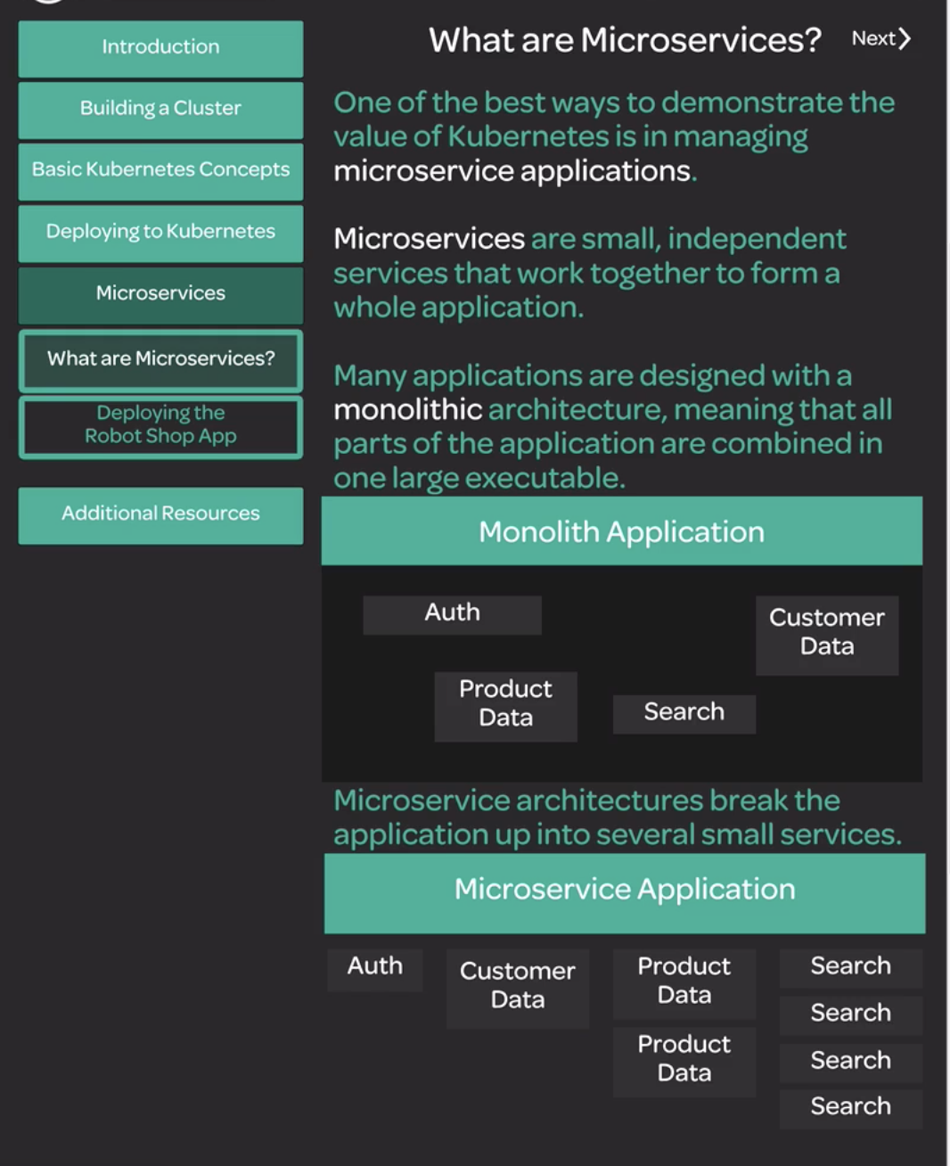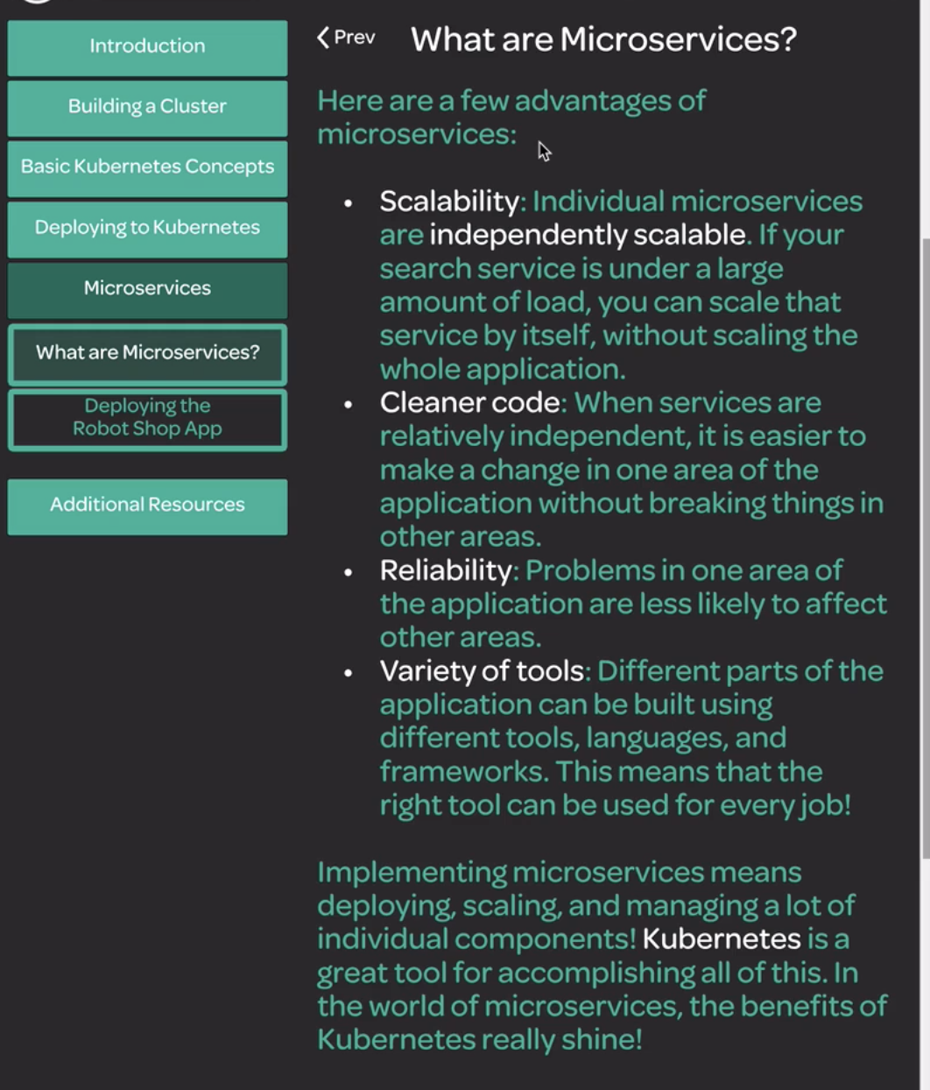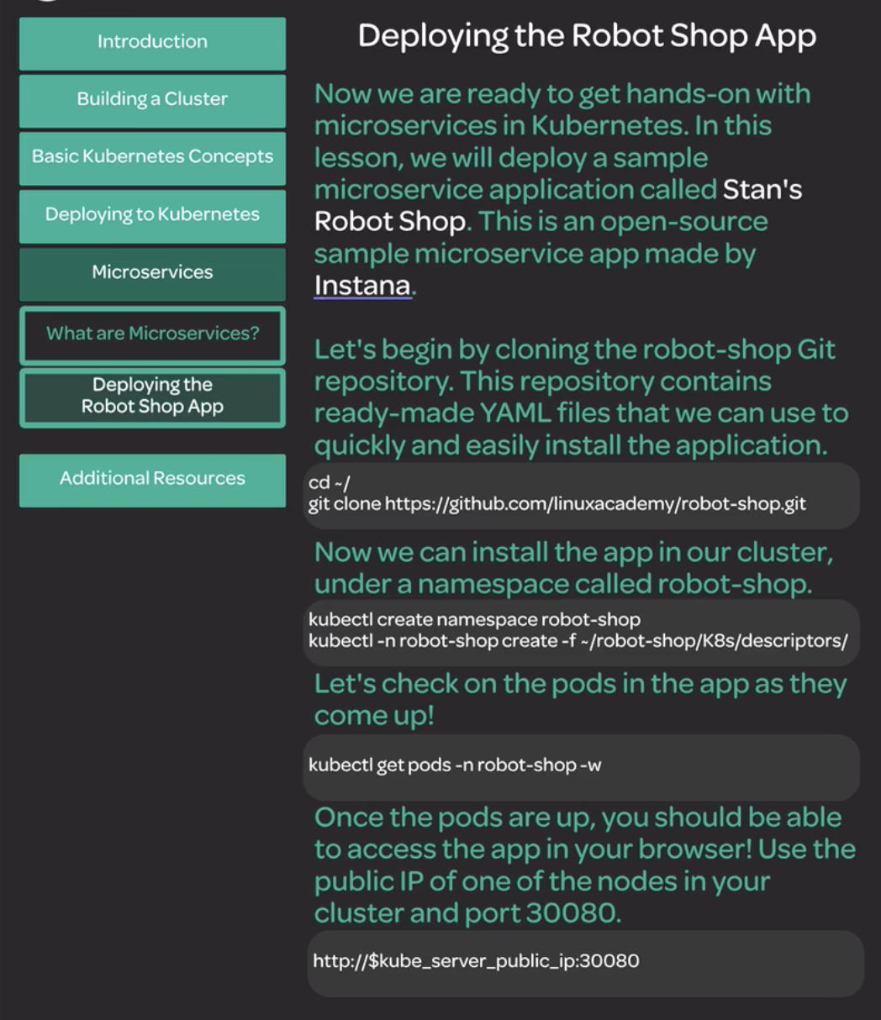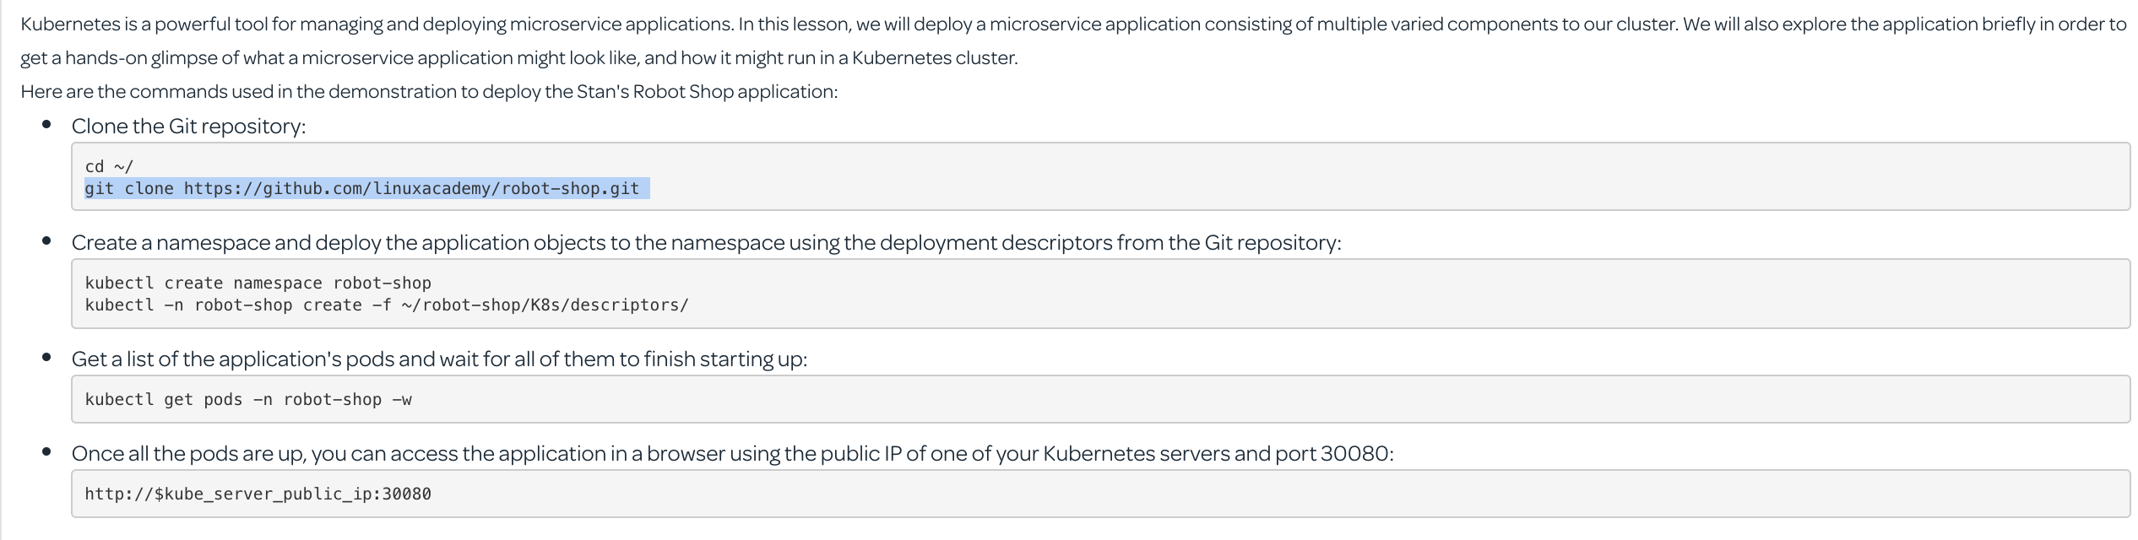

<http://18.140.237.207:30080/>

Note: here 18.140.237.207 is the public IP address of master node.s

You can see a UI for signup and registration.

Scaling up:

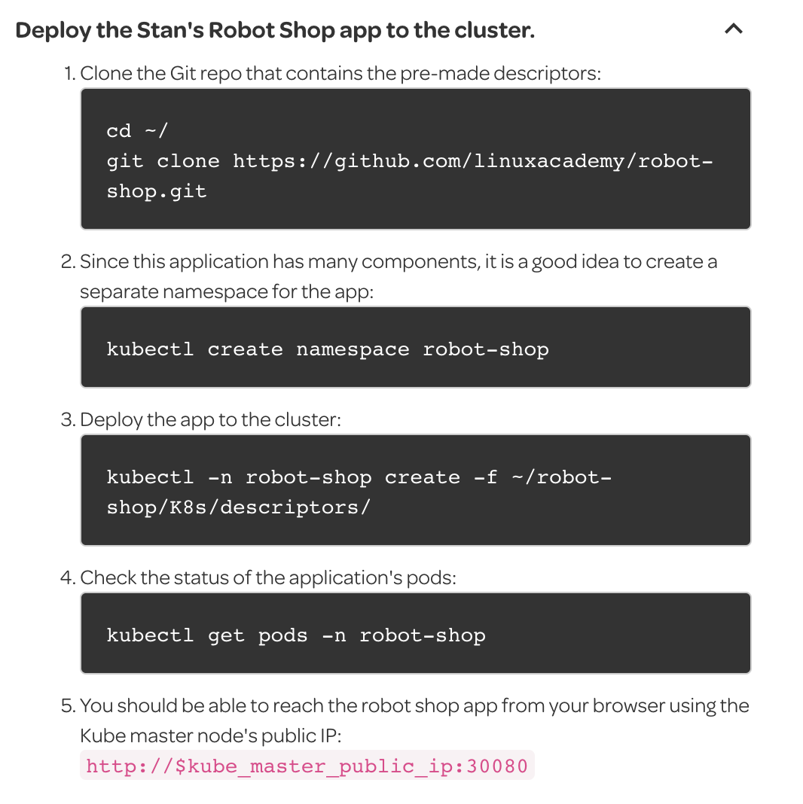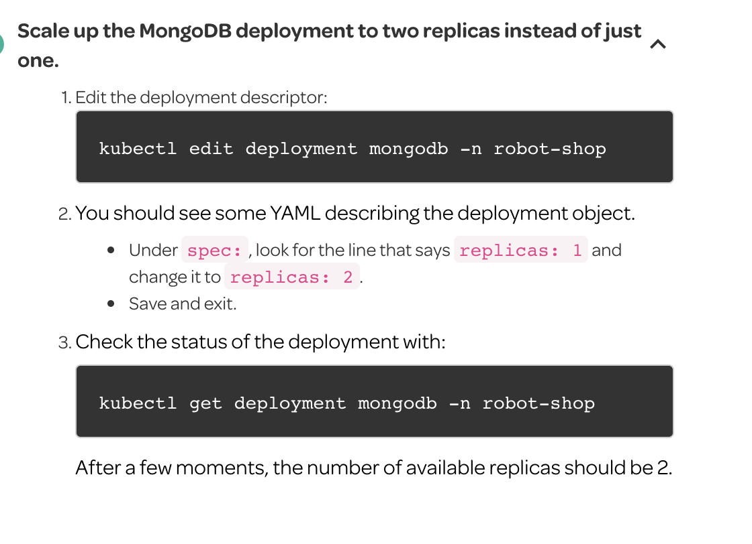

**Deploying a Simple Service to Kubernetes**

**Create a deployment for the store-products service with four replicas.**

|  |
| --- |
| cat << EOF | kubectl apply -f -  apiVersion: apps/v1  kind: Deployment  metadata:  name: store-products  labels:  app: store-products  spec:  replicas: 4  selector:  matchLabels:  app: store-products  template:  metadata:  labels:  app: store-products  spec:  containers:  - name: store-products  image: linuxacademycontent/store-products:1.0.0  ports:  - containerPort: 80  EOF |

**Create a store-products service and verify that you can access it from the busybox testing pod.**

|  |
| --- |
| cat << EOF | kubectl apply -f -  kind: Service  apiVersion: v1  metadata:  name: store-products  spec:  selector:  app: store-products  ports:  - protocol: TCP  port: 80  targetPort: 80  EOF |

|  |
| --- |
| root@bakumar2c:~# kubectl get services  NAME TYPE CLUSTER-IP EXTERNAL-IP PORT(S) AGE  kubernetes ClusterIP 10.96.0.1 <none> 443/TCP 3h34m  store-products ClusterIP 10.110.241.128 <none> 80/TCP 6m46s  root@bakumar2c:~# kubectl get deployments  NAME DESIRED CURRENT UP-TO-DATE AVAILABLE AGE  nginx 2 2 2 2 166m  nginx-deployment 2 2 2 2 128m  store-products 4 4 4 4 7m48s  root@bakumar2c:~# kubectl exec busybox -- curl -s store-products  {  "Products":[  {  "Name":"Apple",  "Price":1000.00,  },  {  "Name":"Banana",  "Price":5.00,  },  {  "Name":"Orange",  "Price":1.00,  },  {  "Name":"Pear",  "Price":0.50,  }  ]  } |

|  |
| --- |
|  |

|  |
| --- |
|  |

|  |
| --- |
|  |

|  |
| --- |
|  |

|  |
| --- |
|  |

|  |
| --- |
|  |

|  |
| --- |
|  |

|  |
| --- |
|  |

|  |
| --- |
|  |

|  |
| --- |
|  |

|  |
| --- |
|  |

|  |
| --- |
|  |

|  |
| --- |
|  |

|  |
| --- |
|  |

|  |
| --- |
|  |

|  |
| --- |
|  |

|  |
| --- |
|  |

|  |
| --- |
|  |

|  |
| --- |
|  |

|  |
| --- |
|  |

|  |
| --- |
|  |

|  |
| --- |
|  |

|  |
| --- |
|  |

|  |
| --- |
|  |

|  |
| --- |
|  |

|  |
| --- |
|  |

|  |
| --- |
|  |

|  |
| --- |
|  |

|  |
| --- |
|  |

|  |
| --- |
|  |

|  |
| --- |
|  |

|  |
| --- |
|  |

|  |
| --- |
|  |

|  |
| --- |
|  |

|  |
| --- |
|  |

|  |
| --- |
|  |

|  |
| --- |
|  |

|  |
| --- |
|  |

|  |
| --- |
|  |

|  |
| --- |
|  |

|  |
| --- |
|  |

|  |
| --- |
|  |

|  |
| --- |
|  |

|  |
| --- |
|  |

|  |
| --- |
|  |

|  |
| --- |
|  |

|  |
| --- |
|  |

|  |
| --- |
|  |

|  |
| --- |
|  |

|  |
| --- |
|  |

|  |
| --- |
|  |

|  |
| --- |
|  |

|  |
| --- |
|  |

|  |
| --- |
|  |

|  |
| --- |
|  |

|  |
| --- |
|  |

|  |
| --- |
|  |

|  |
| --- |
|  |

|  |
| --- |
|  |

|  |
| --- |
|  |

|  |
| --- |
|  |

|  |
| --- |
|  |